**Ideation Phase**

**Empathize & Discover**

|  |  |
| --- | --- |
| **Date** | 21 June 2025 |
| **Team ID** | LTVIP2025TMID58987 |
| **Project Name** | **DocSpot:** Seamless Appointment Booking for Health |
| **Maximum Marks** | 4 Marks |

**Empathy Map Canvas:**

An Empathy Map Canvas is a visual tool used to understand users better. It helps teams see the product or service through the user's eyes by exploring:

* What the user thinks
* What the user feels
* What the user says
* What the user does

This approach uncovers key insights about the user's experiences, motivations, and pain points.

**Why Use an Empathy Map?**

* To gain deeper user understanding beyond just facts or numbers.
* To identify real needs, frustrations, and goals of the user.
* To encourage team empathy—the core of user-centered design.

**How It Supports Problem-Solving**

Before designing any solution, it's important to understand who you're helping and what they truly need.

Using an Empathy Map helps:

* Understand the **user’s mindset and emotions.**
* Discover **real problems** and user **pain points.**
* Avoid **false assumptions** about user behaviour.
* Align the team with a **shared understanding** of the user.
* Design **more relevant, user-focused solutions.**
* Identify **opportunities for improvement** in the user experience.

**Example:**

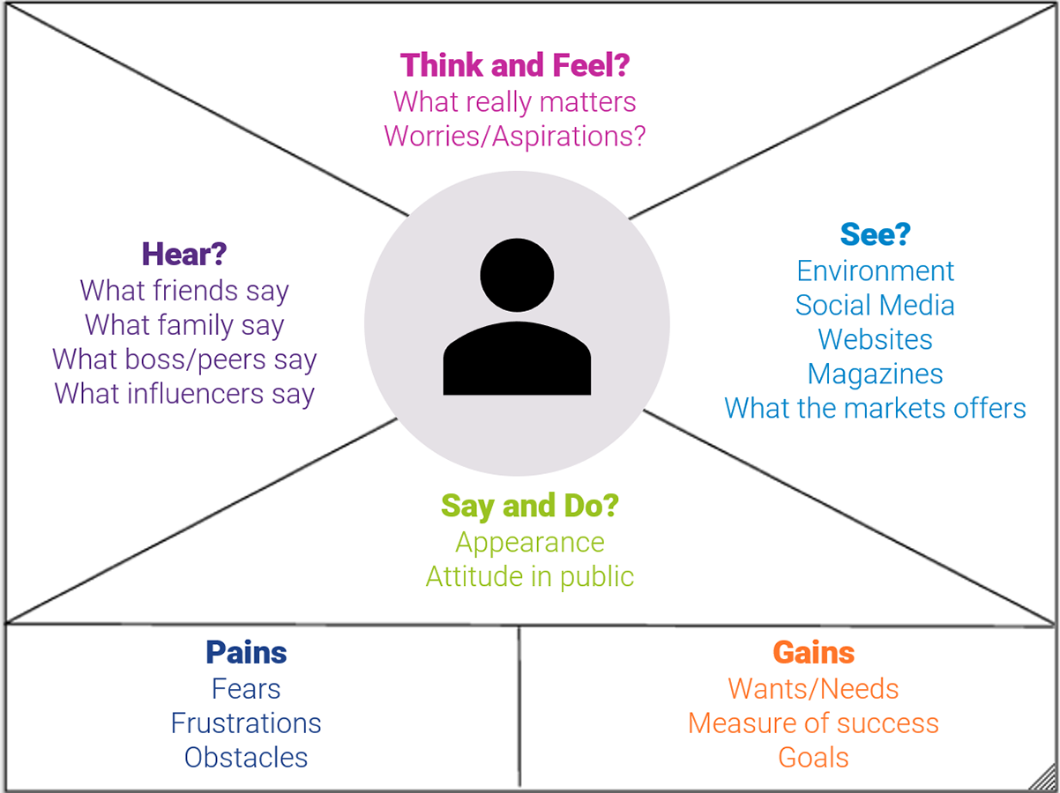

**Reference:** <https://www.mural.co/templates/empathy-map-canvas>

**Example:** LearnHub

This empathy map illustrates the thoughts, feelings, behaviors, and expressions of a health-conscious persona. It provides a structured understanding of user concerns related to fitness and healthy eating.

# Says:

“It’s too hard to find healthy options when eating out.”

**Thinks:**

“Am I exercising enough compared to my peers?”

**Does:**

Uses a fitness tracker daily.

**Feels:**

Frustrated with my lack of progress.

